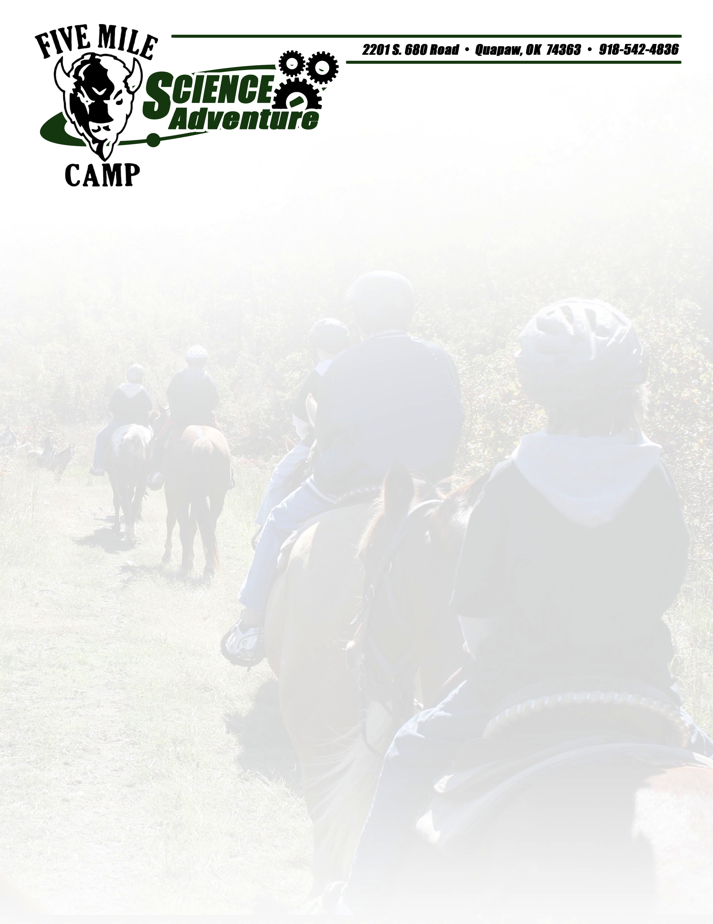

Permission Slip

Five Mile Camp Zip Line and Horseback Riding programs use a variety of activities including warm-ups, games, and team building initiatives. While some of these activities can be physically demanding, they are designed to be within the capability of anyone who is in reasonably good health.

All ropes course and horseback riding activities are presented on a challenge by choice basis, meaning that the participant choose their own level of participation. Although, safety is an extremely high priority of all zip line and horseback riding activities, there is a risk, which must be assumed by each participant, that he or she may suffer an emotional or physical injury. The ropes course and zip lines are NOT recommended for participants that are pregnant, have a heart condition, or have head, neck or back injuries and not weigh more than 250 lbs.

The information requested on this form is to help inform Five Mile Camp staff of any pre-existing medical conditions, and to help determine if consultation with your physician is recommended prior to participating.

PARENT/GUARDIAN PERMISSION STATEMENT

Registration cannot be made without signature.

I give my full permission for my child to attend and participate in all phases of the camp activities. My child may be treated by the camp staff for minor ailments and by a physician when deemed necessary. Therefore, during my absence, I authorize the Five Mile Camp staff to seek any emergency, outpatient, medical, or surgical treatment that the camp staff or physician, the emergency room physicians, and/or medical staff from the local hospital may deem necessary.

I give permission to the school to release my child immunization chart, medical records and a copy of our insurance card (if available). My child has permission to participate in the zip line, ropes course, horses, or any camp activity.

STUDENT NAME (please print):__________________________________________________________

PARENT/GUARDIAN NAME (please print): ____________________________________________

PARENT/GUARDIAN NAME (signature):________________________________________________

DATE: __________________________

MEDICAL INFORMATION

DO YOU HAVE ANY PREEXISTING MEDICAL CONDITIONS?
(Please list conditions such as allergies, recent surgery, conditions that require medication, circulatory or respiratory conditions, and any other conditions that you may have.)

NO_____________ YES_____________

IF YES, PLEASE EXPLAIN:___________________________________________________________________

_________________________________________________________________________________________________

PARENT’S OR LEGAL GUARDIAN’S ADDITIONAL INDEMNIFICATION
(Must be completed for participants under the age of 18)

In consideration of _______________________________(print minor’s name) (“Minor”) being permitted by Five Mile Camp to participate in its activities and to use its equipment and facilities, I further agree to indemnify and hold harmless Five Mile Camp from any and all claims which are brought by, or on behalf of Minor, and which are in any way connected with such use or participation by Minor.
I understand and agree that Five Mile Camp cannot be responsible for supervision of minors when they are not actively participating in our programs. At all times, supervision of minors is the responsibility of the group leaders, parents, or guardians. I understand that if the participant is pregnant, has a heart condition, or has head, neck or back injuries, 5 Mile Camp is not responsible for any further injury.

Parent’s or Legal Guardian’s Signature:_________________________________________________

Print Name:___________________________________________________ Date:________________

Zip Line Rider/ Ropes Course Responsibility

This zip line is not recommended for participants that are pregnant or have neck, bone, or back injuries, high blood pressure, heart problems, recent surgery or extreme fear of heights.
A participant will be denied entry when they are under the influence of alcohol, controlled substance, or drug, or any combination thereof.

Requirements: Rider must

- Weigh less than 250 lbs.
- Remain upright.
- Never disconnect a safety device unless at the direction of an instructor.
- Wear properly fitted and secured harness.
- Secure all loose articles.
- Wear closed toed shoes.
- Enter and Exit the zip line at designated areas.

